**Project 1- RPI SETUP**

1. **Functional RPi setup:**

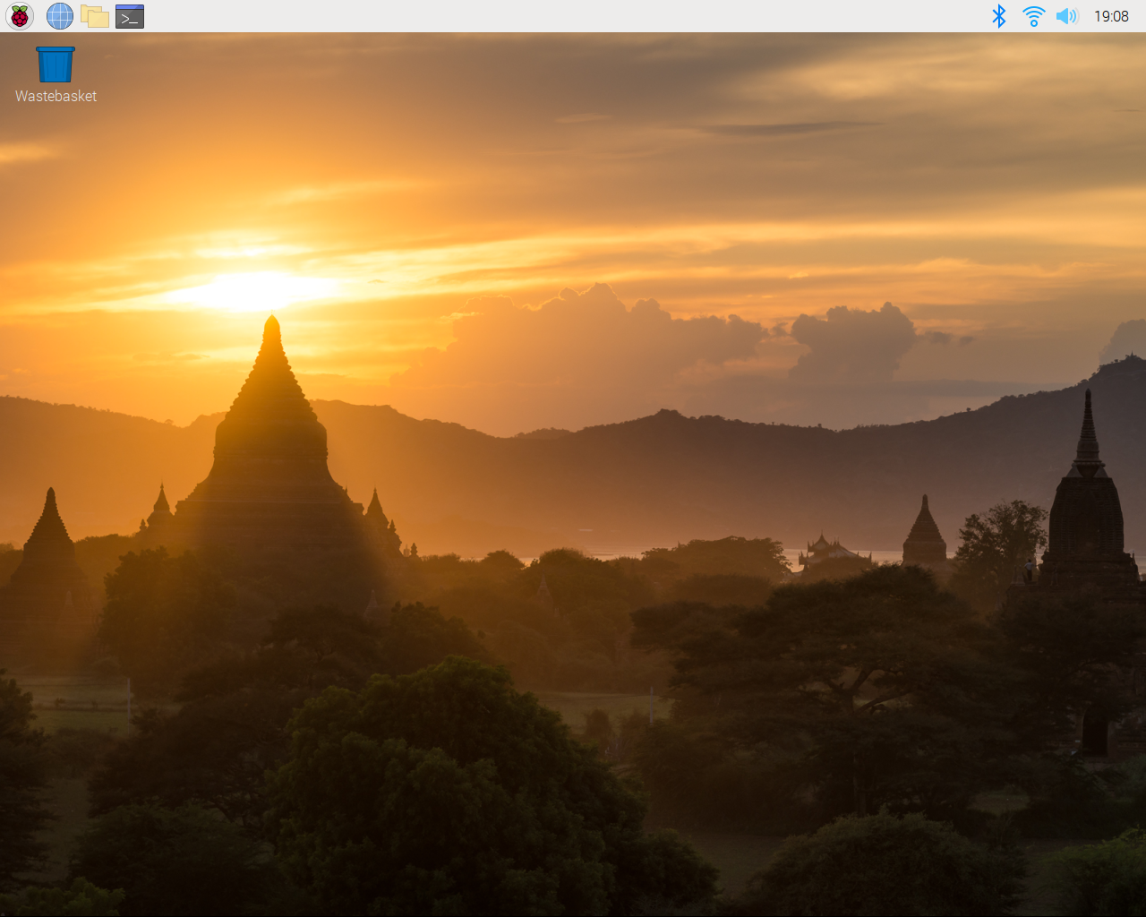

1. **Python3 hello world program output:**

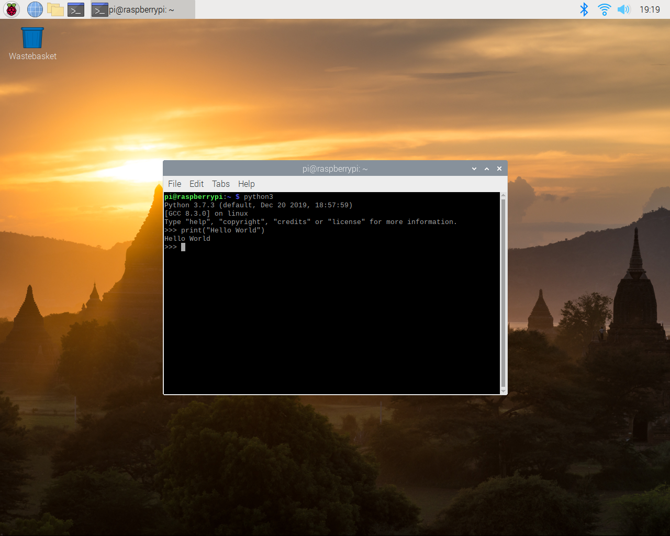

1. **C/C++ hello world program output:**

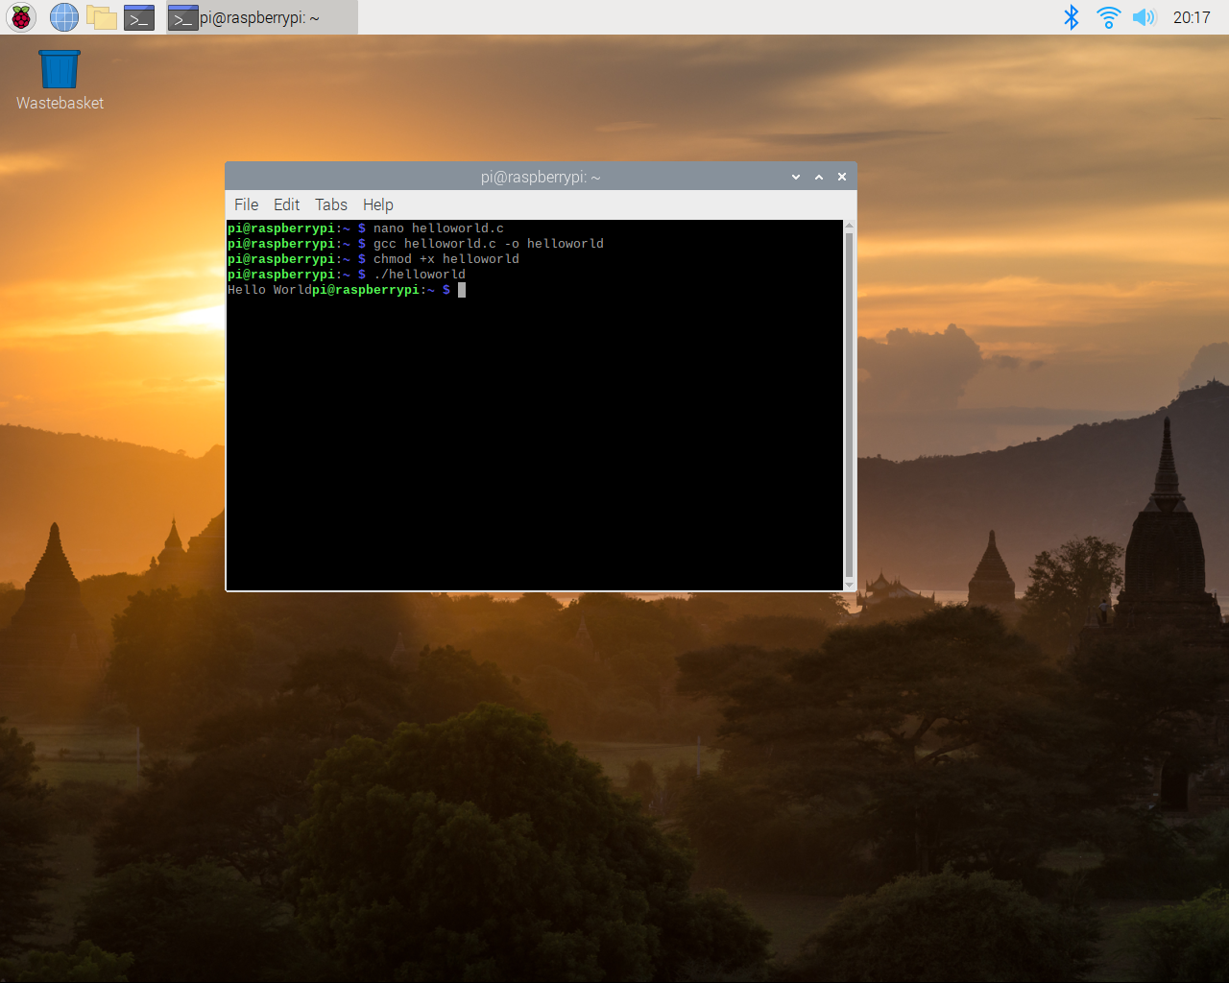

**Approach to project:**

In this project we have to setup our Raspberry pi model 3B+ and install python3 and C/C++ compiler to get output of hello world program. First of all, download Raspbian Buster latest from the Raspberry Pi official website and copy this OS image into your SD card using image writing tools e.g. Etcher. After copying put your SD card into the raspberry pi and turn on, at this point I imagine our raspberry pi I s already set with display screen and other devices like mouse and keyboard etc. When you boot up your raspberry pi, it will show some initial setting about your locale, keyboard setting, date& time, RPi password etc. You can change password at this point and also connect your raspberry pi with the Wi-Fi or Ethernet according to which is easily available.

Now, open the terminal and check the python version by using command “python –version”. If the python version is 3 or some other version of 3 like 3.6 or 3.7 then ok. Otherwise if version is latest than python3 then you have to update it. So, for updating the python into latest version you first have to remove the previous installed python version and then install latest one. It is done by using the commands given in project file.

Next, we have to install the C/C++ compiler in raspberry pi using terminal window. So, we have to use commands to install C/C++ compiler in the raspberry pi. We search on google and install C/C++ compiler in raspberry pi using terminal window.

Now, at this point we have to write python hello world program and also the same program using C/C++. First, we go to terminal and type “python” then the terminal will run python3. Now here you can write your program or can open your program if already written and located in some other directory. Write “print (“Hello world”) and press ENTER will run this command in python compiler and show output. Similarly, in C/C++ compiler we can write our hello world program by importing standard input/output in the program and save this program in a directory. Then we call this program by calling program directory, the hello world program will run in C/C++ compiler and show output.

In this way we complete our first project by using raspberry pi.